Experiments
Exp 1:Flashing of Led using AT89C51 Microcontroller using Proteus
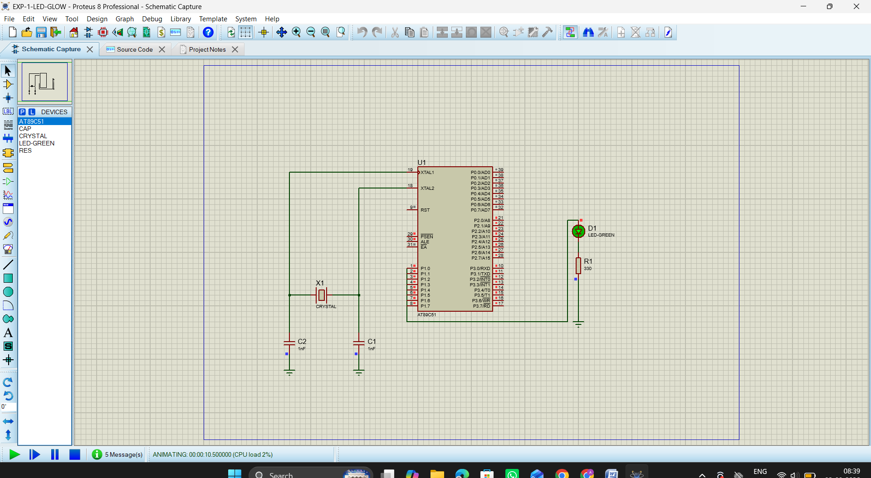
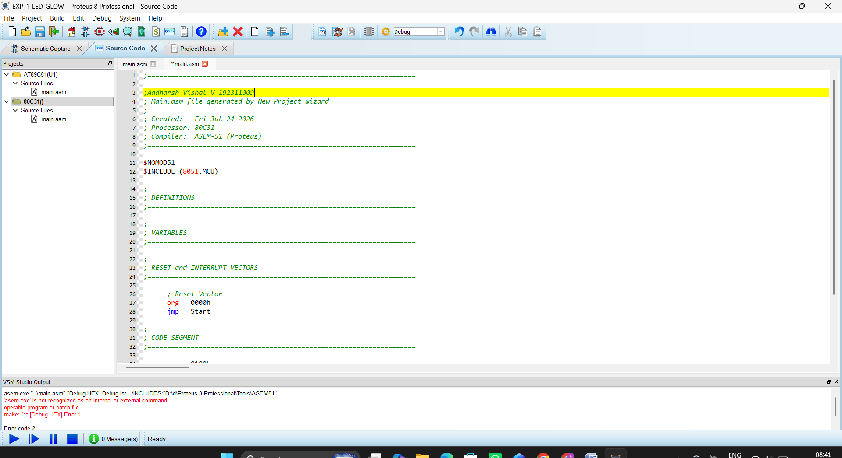
Exp 2 :Generation of Square Wave using Proteus
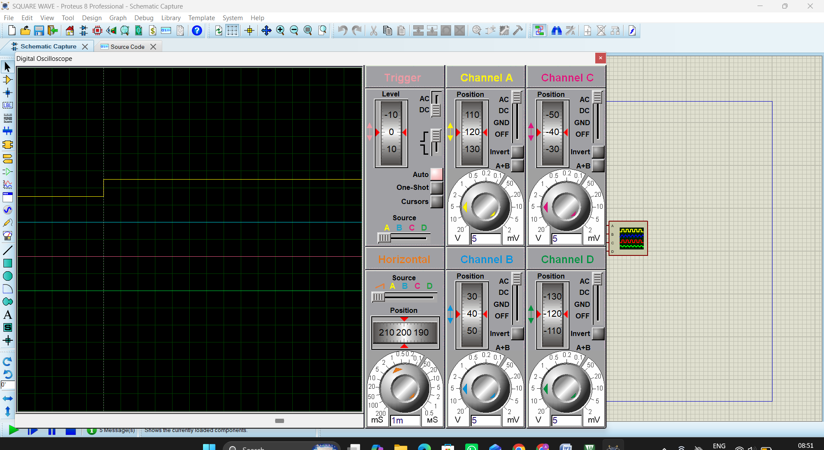
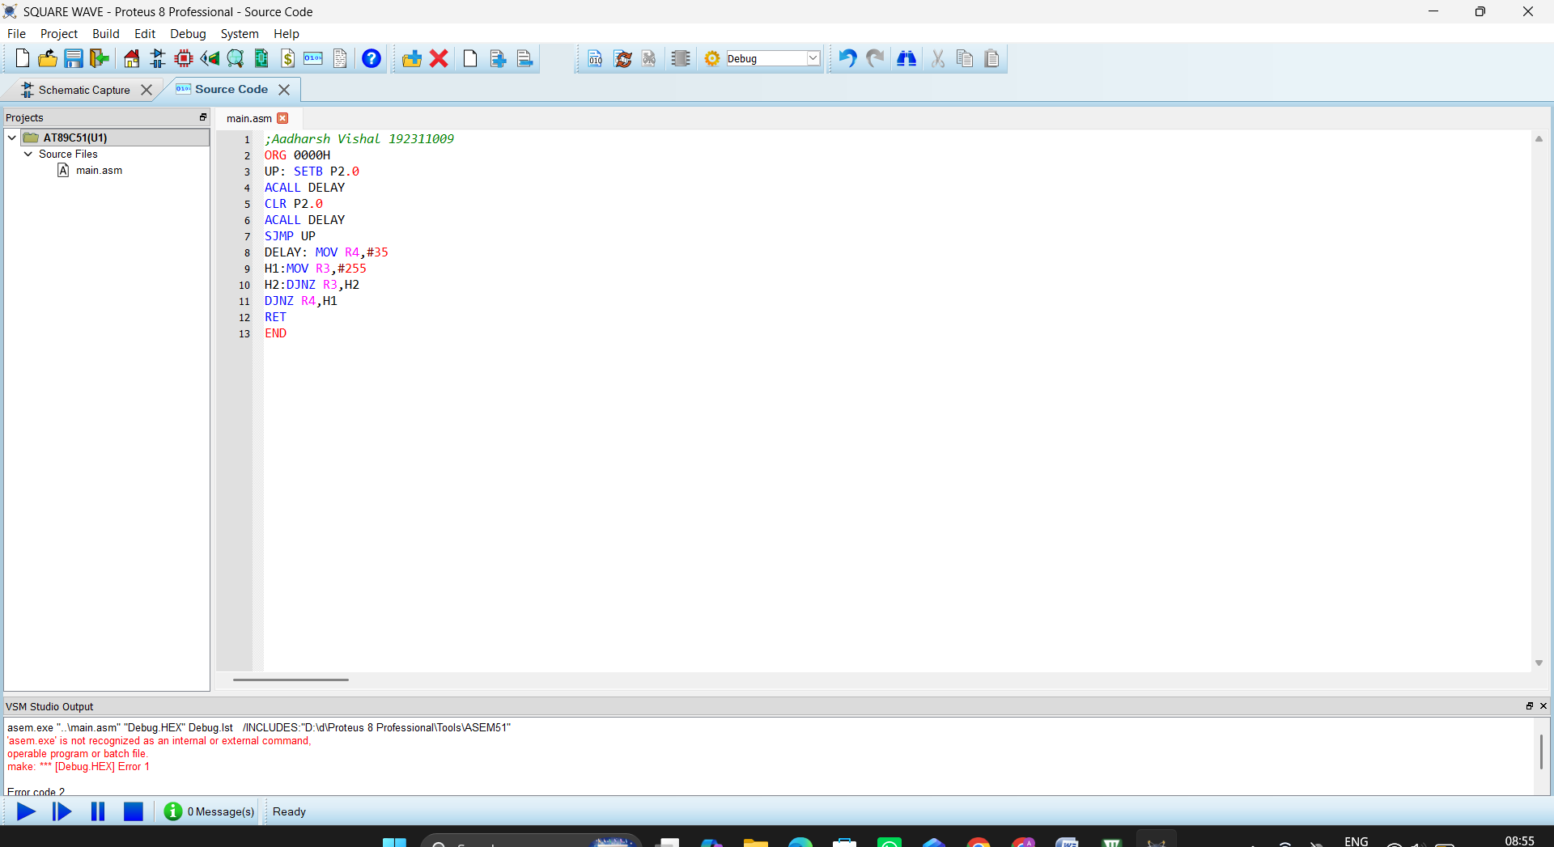

Exp 3: Stepper Motor Using AT89C51 using Proteus
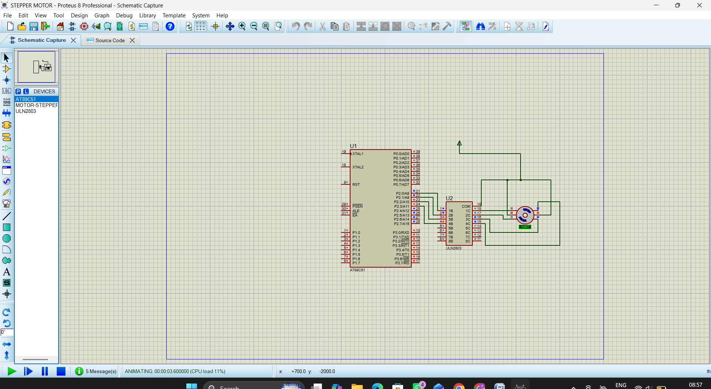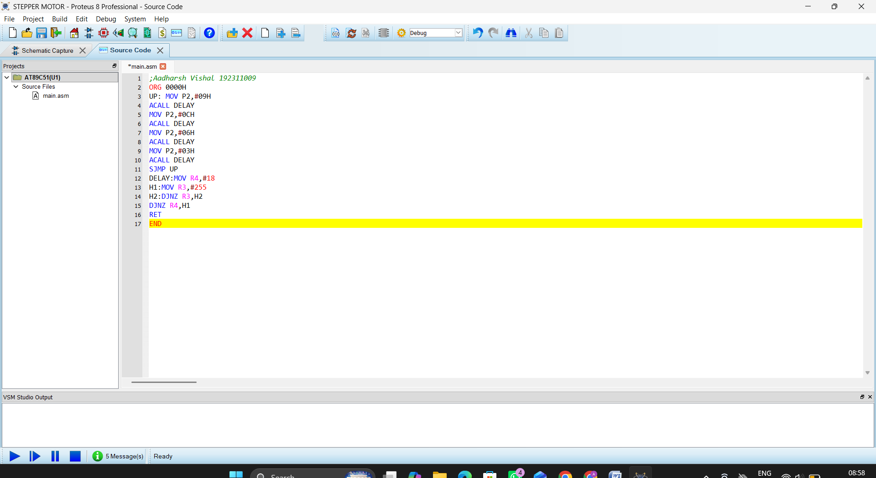

Exp 4: 7 Segment Display Using AT89C51 using Proteus
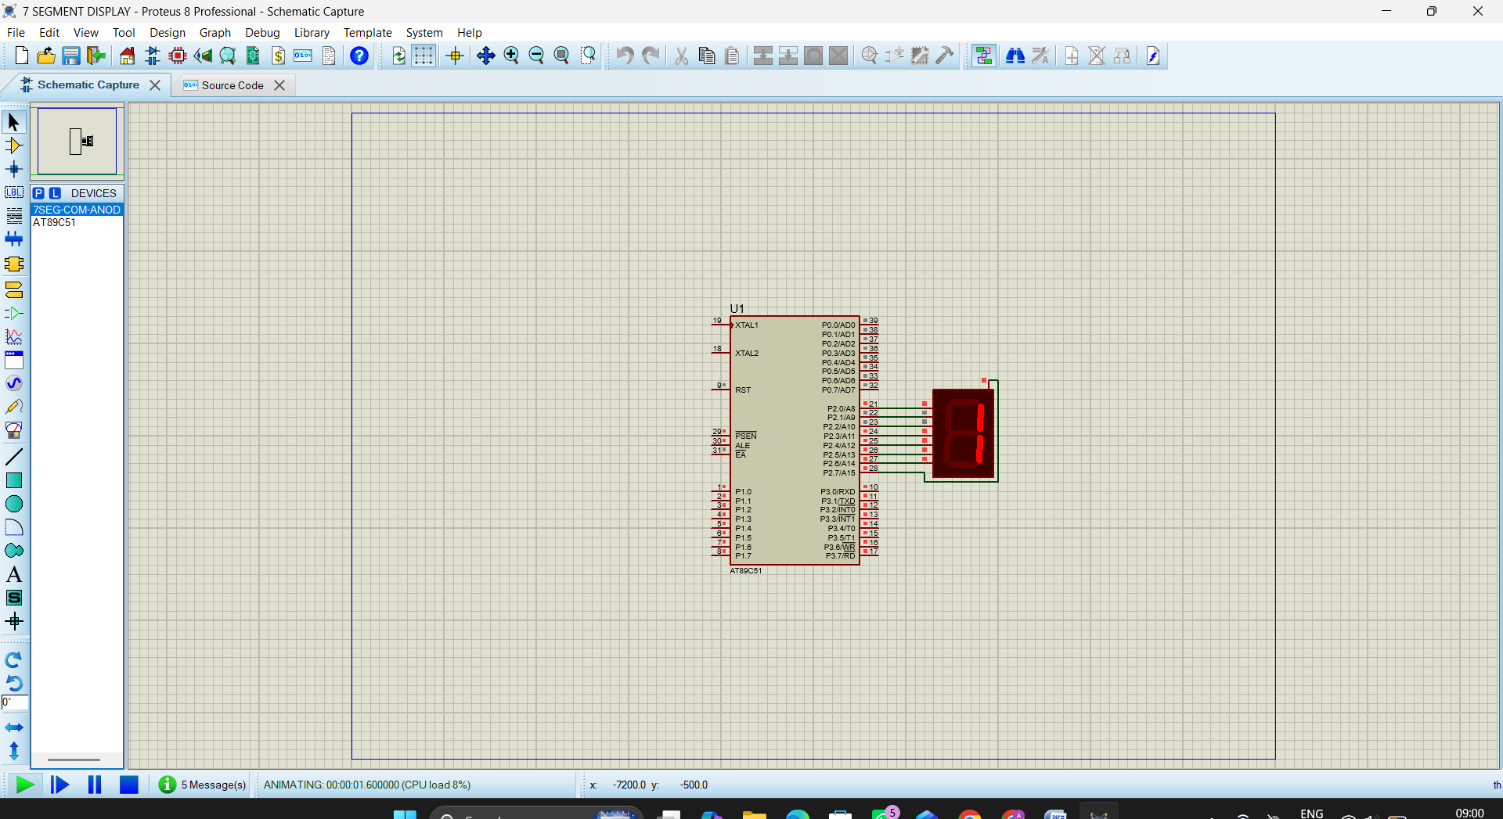
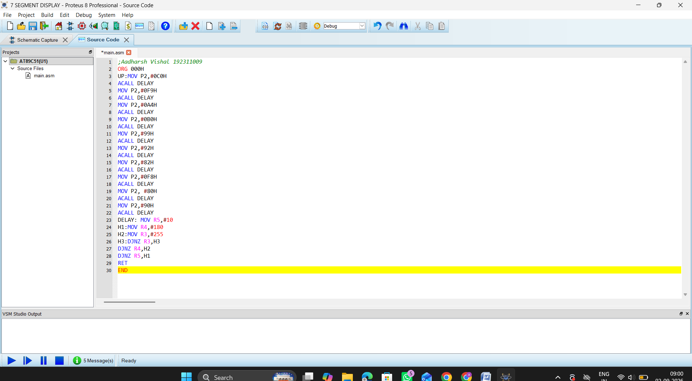

Exp 5: Arduino based Manual Electronic Counter using Proteus
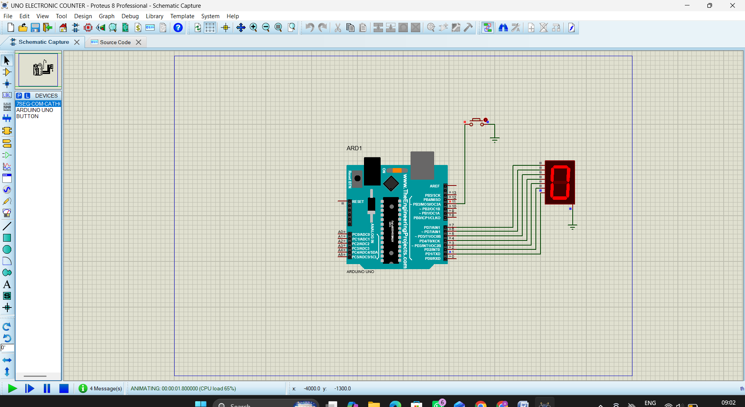
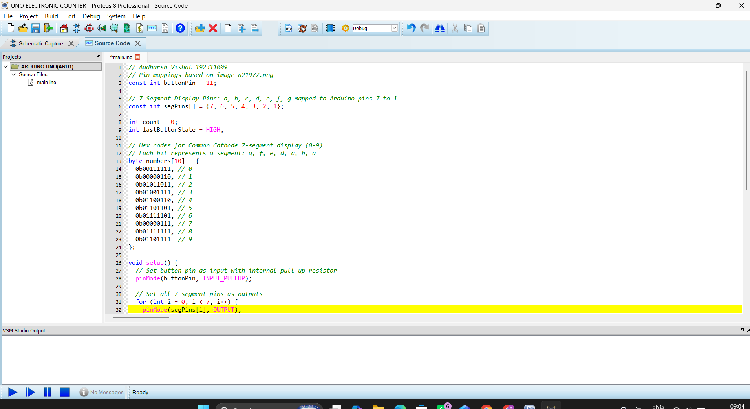

Exp 6: Arduino to 16x2 LCD Display using Proteus
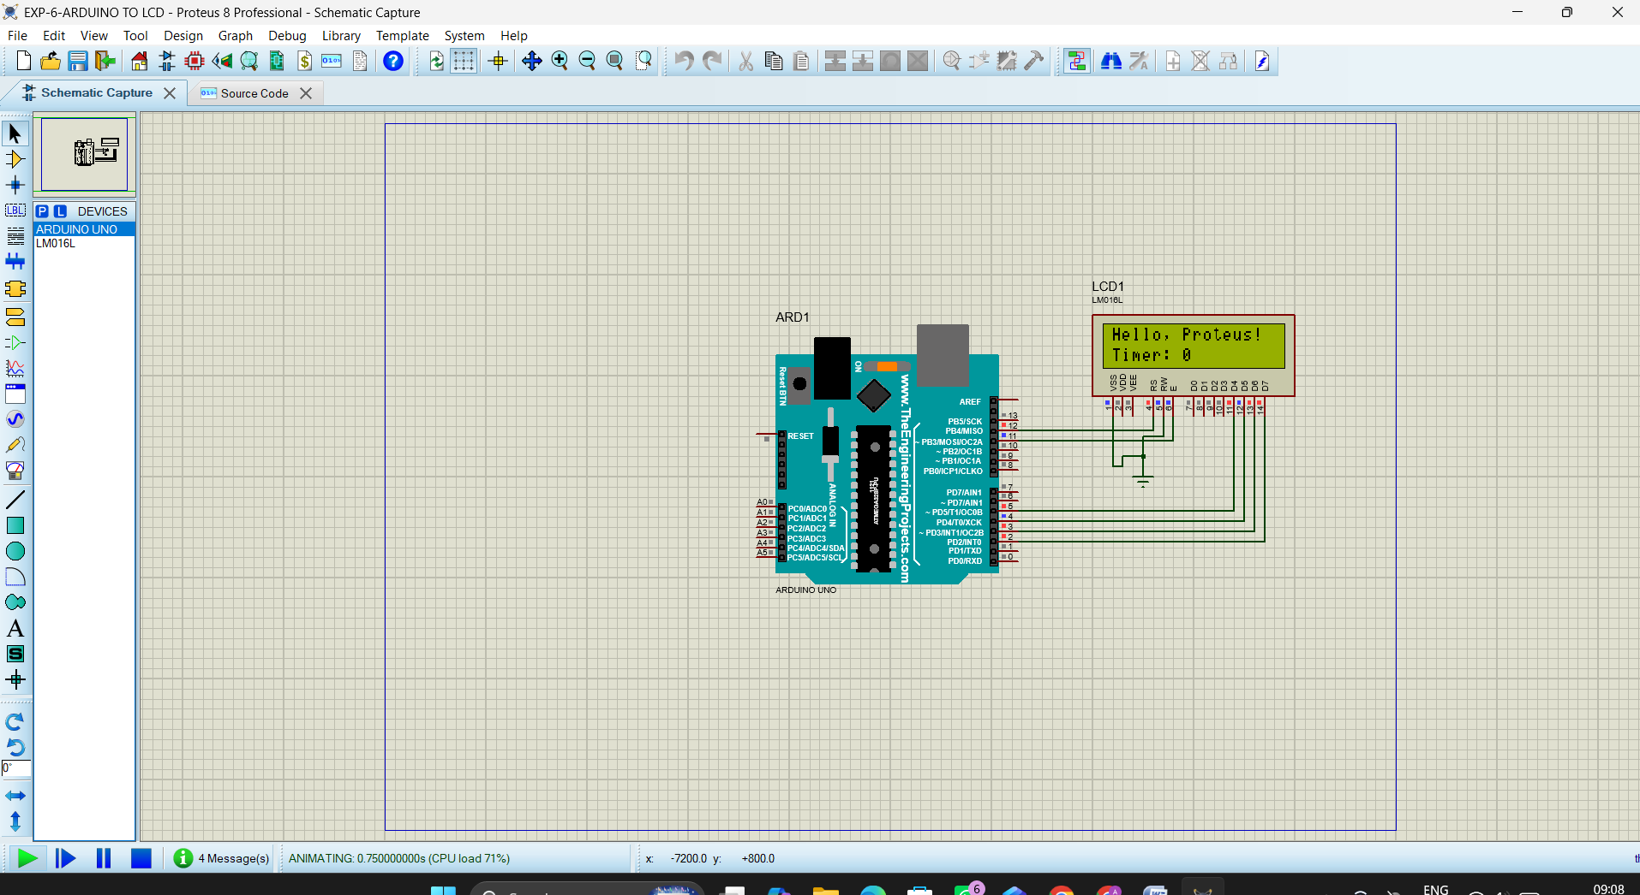
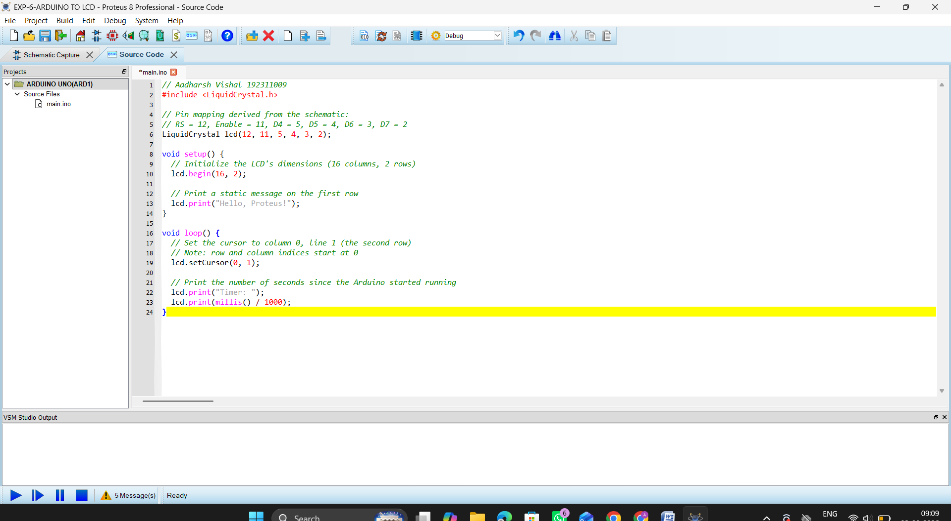

Exp 7: Serial Communication using Arduino with Proteus
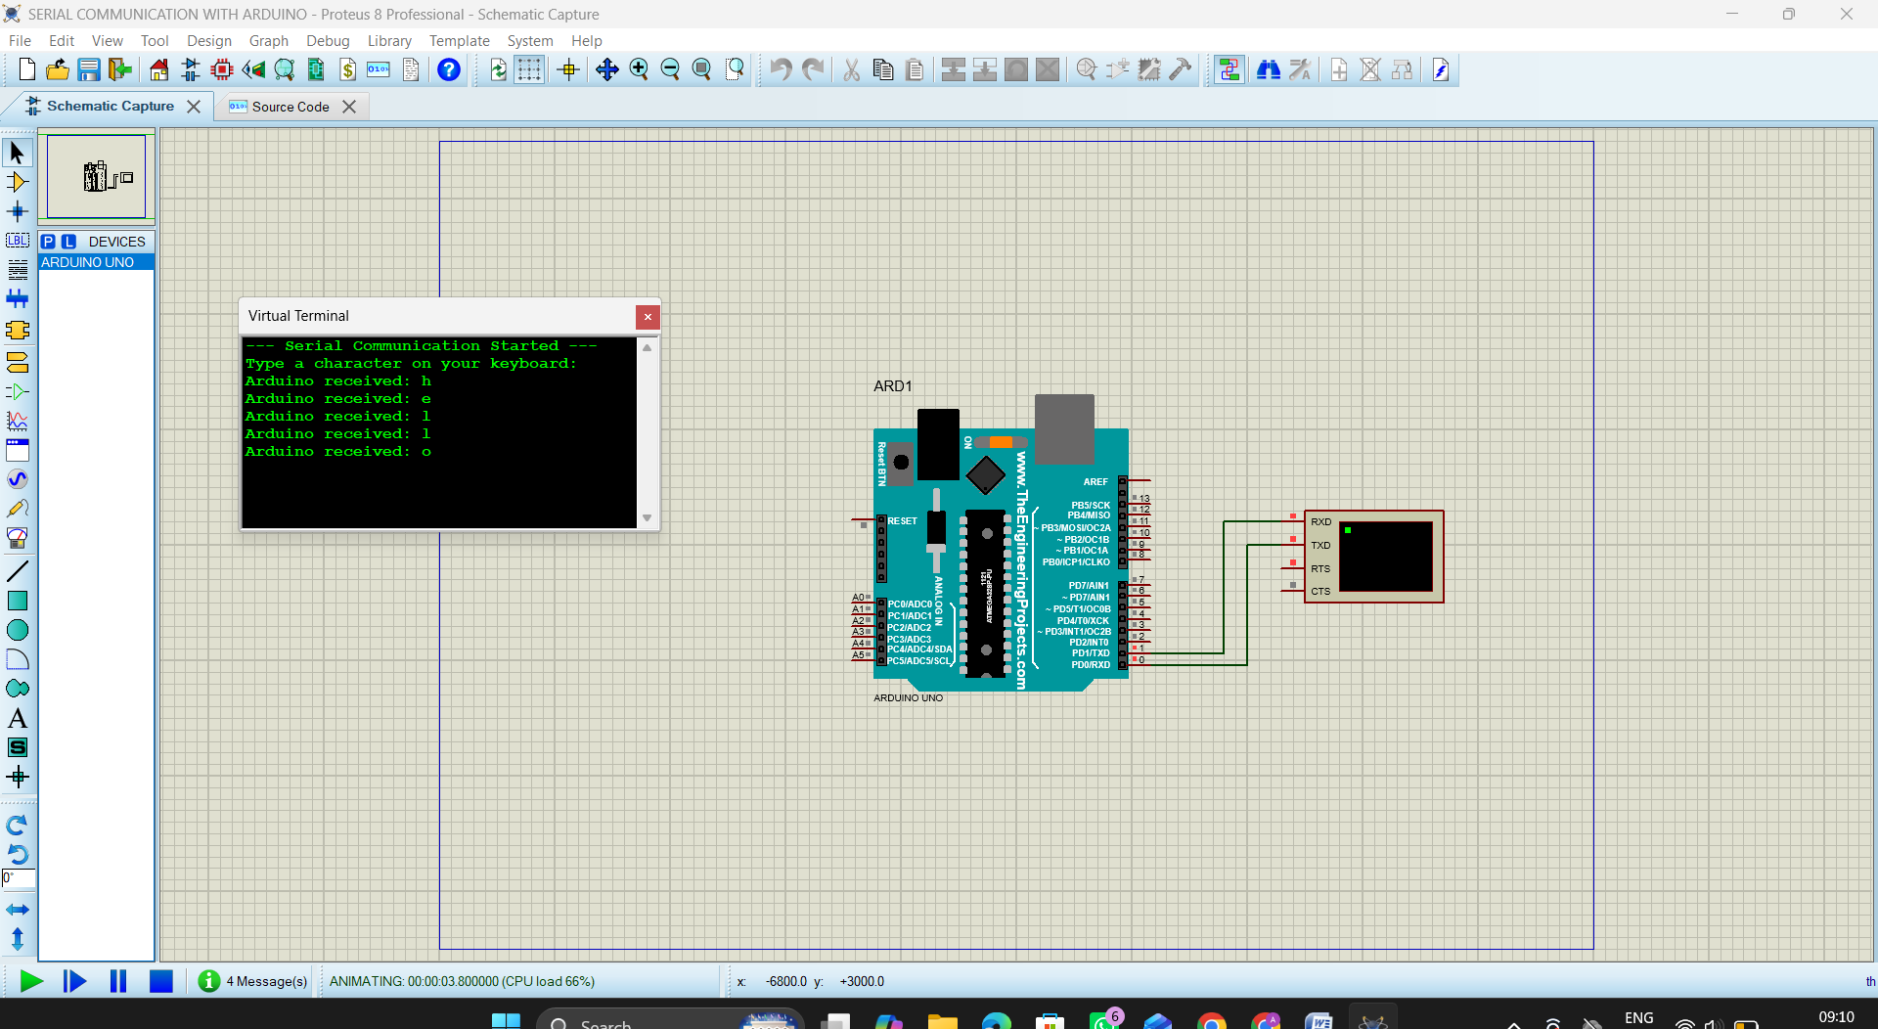
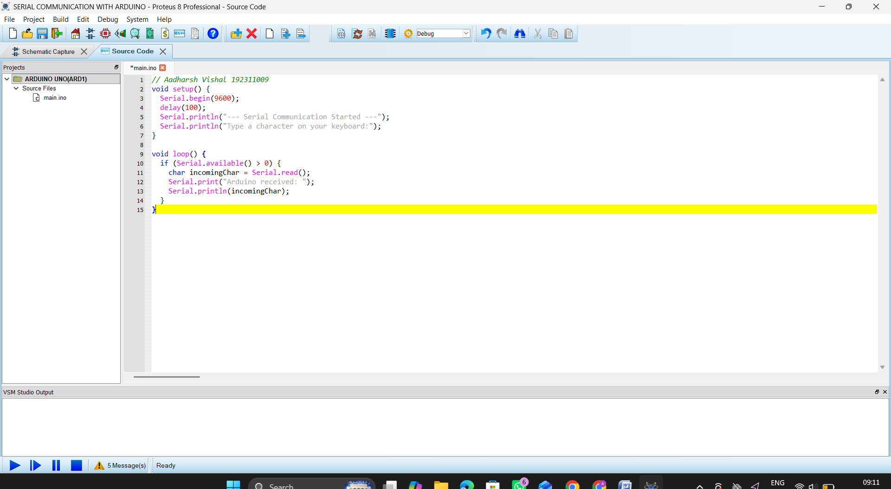

Exp 8: Gas Sensor MQ-2 in Proteus using Arduino
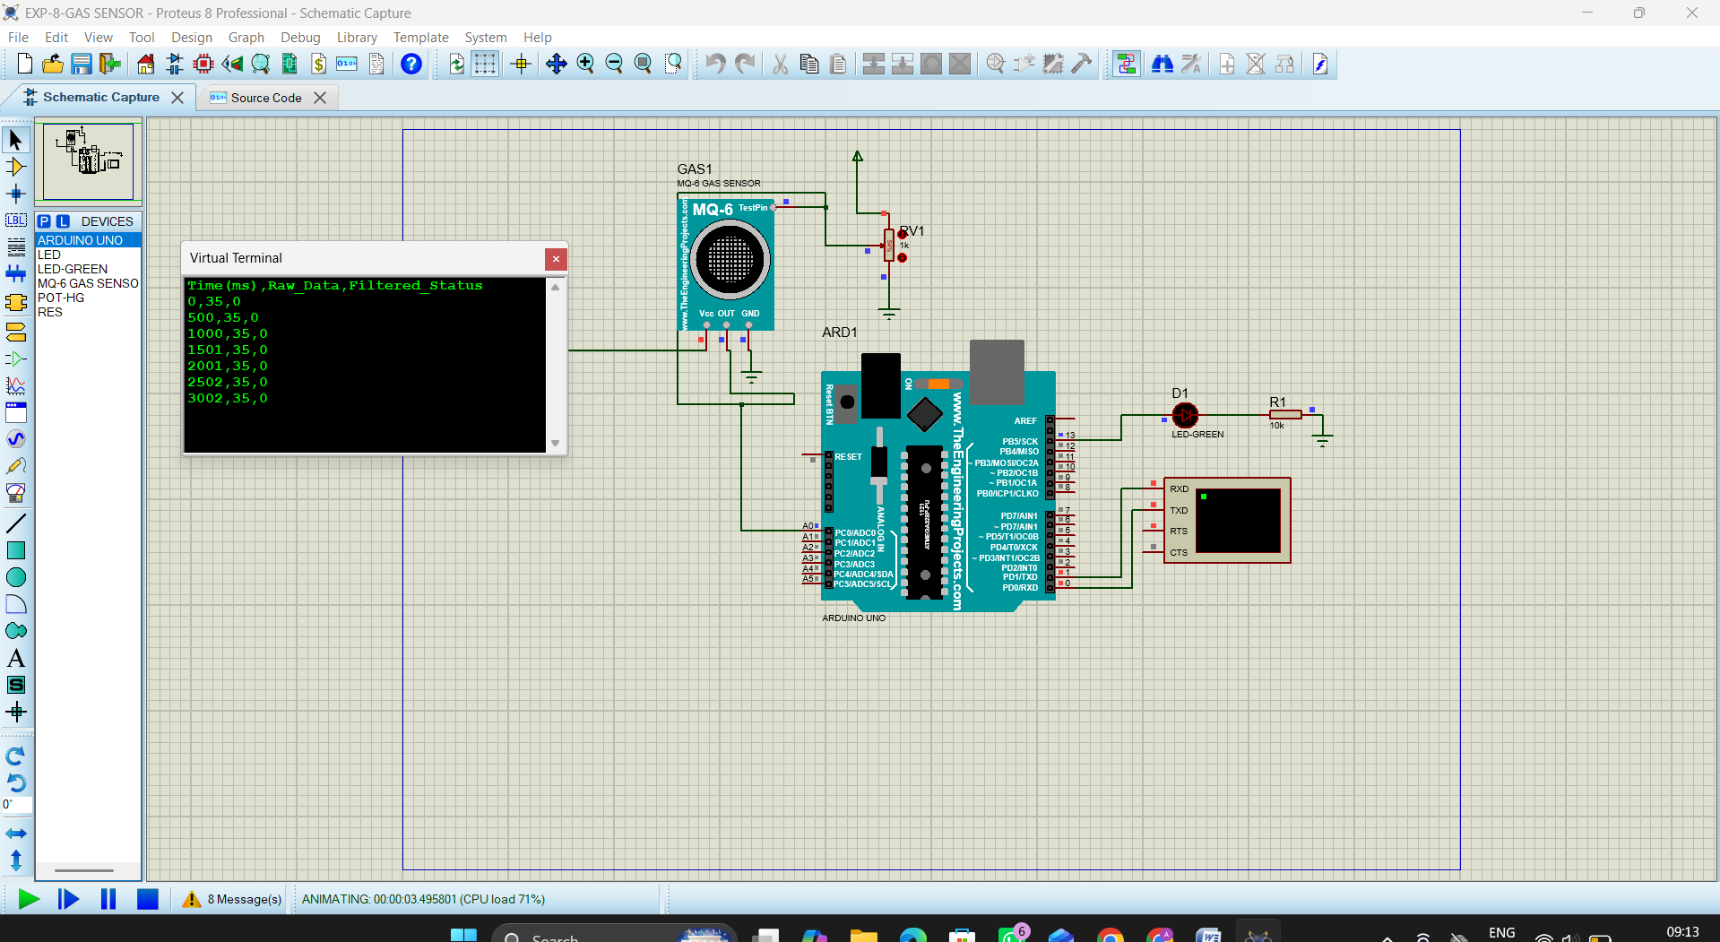
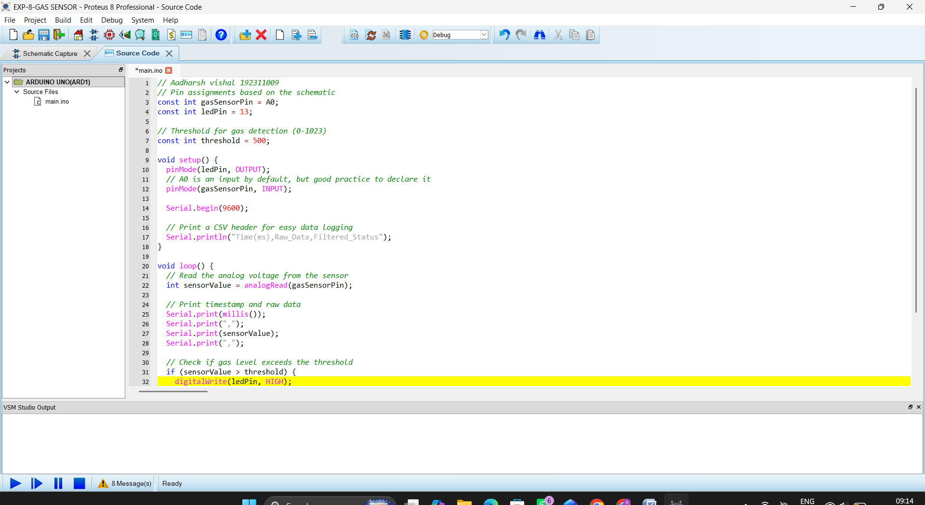

Exp 9: Ultrasonic Sensor in Proteus using Arduino
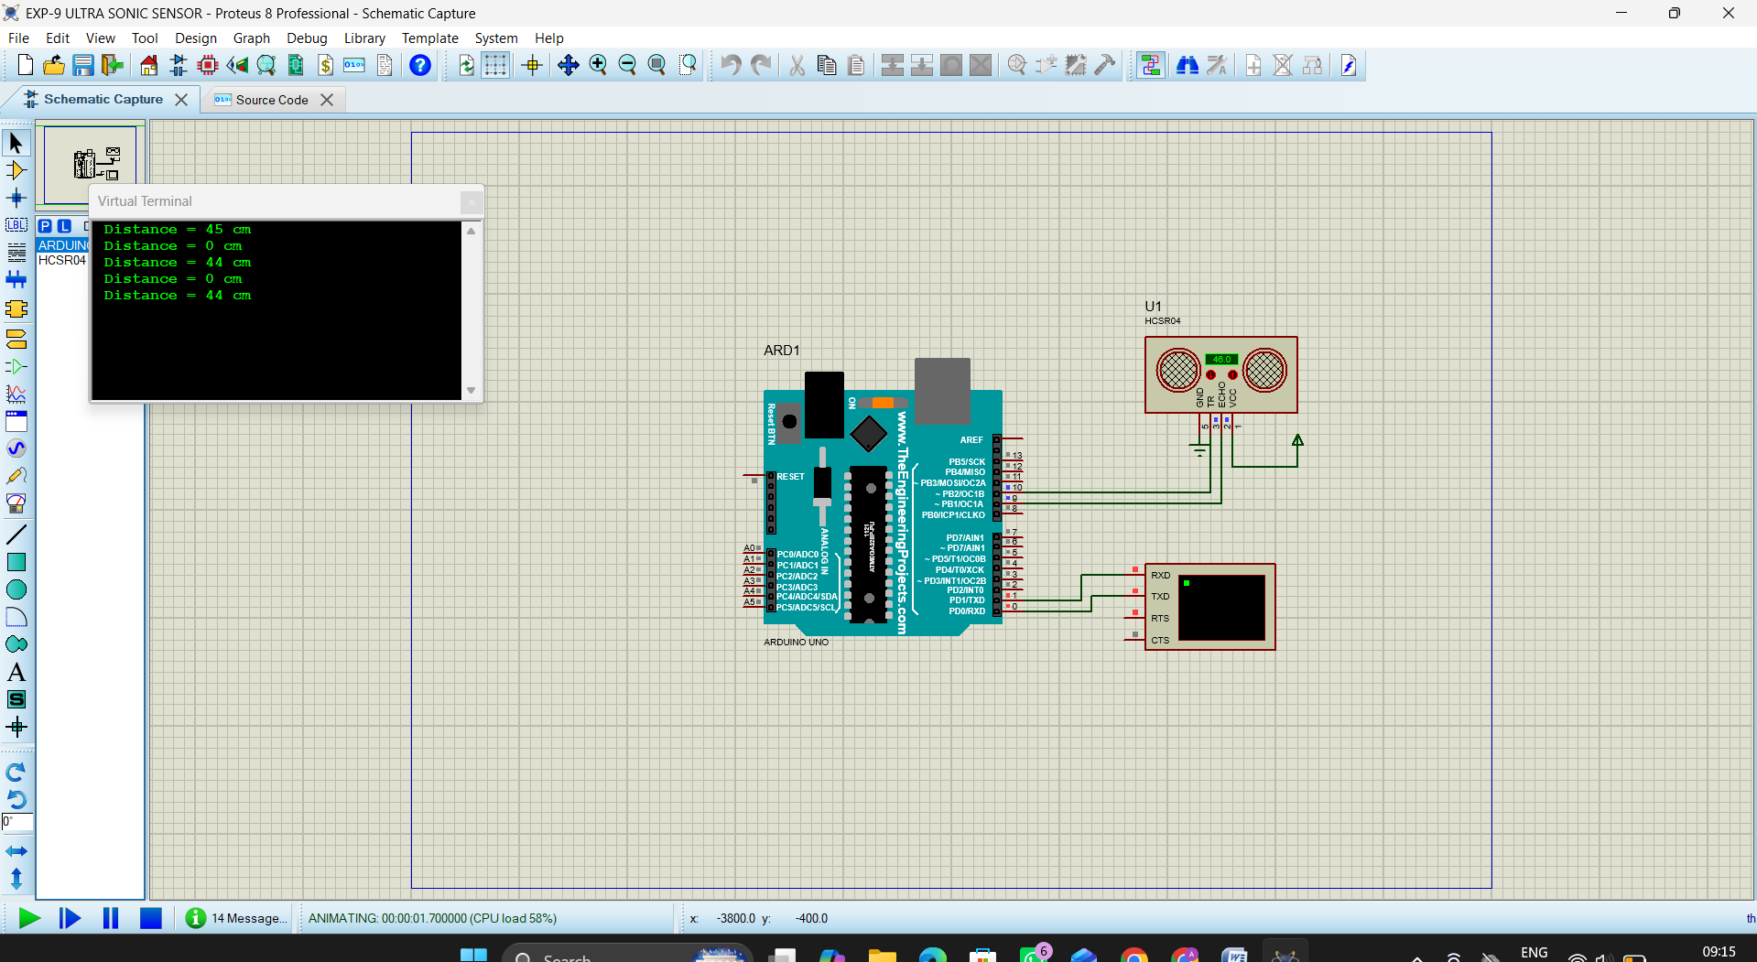
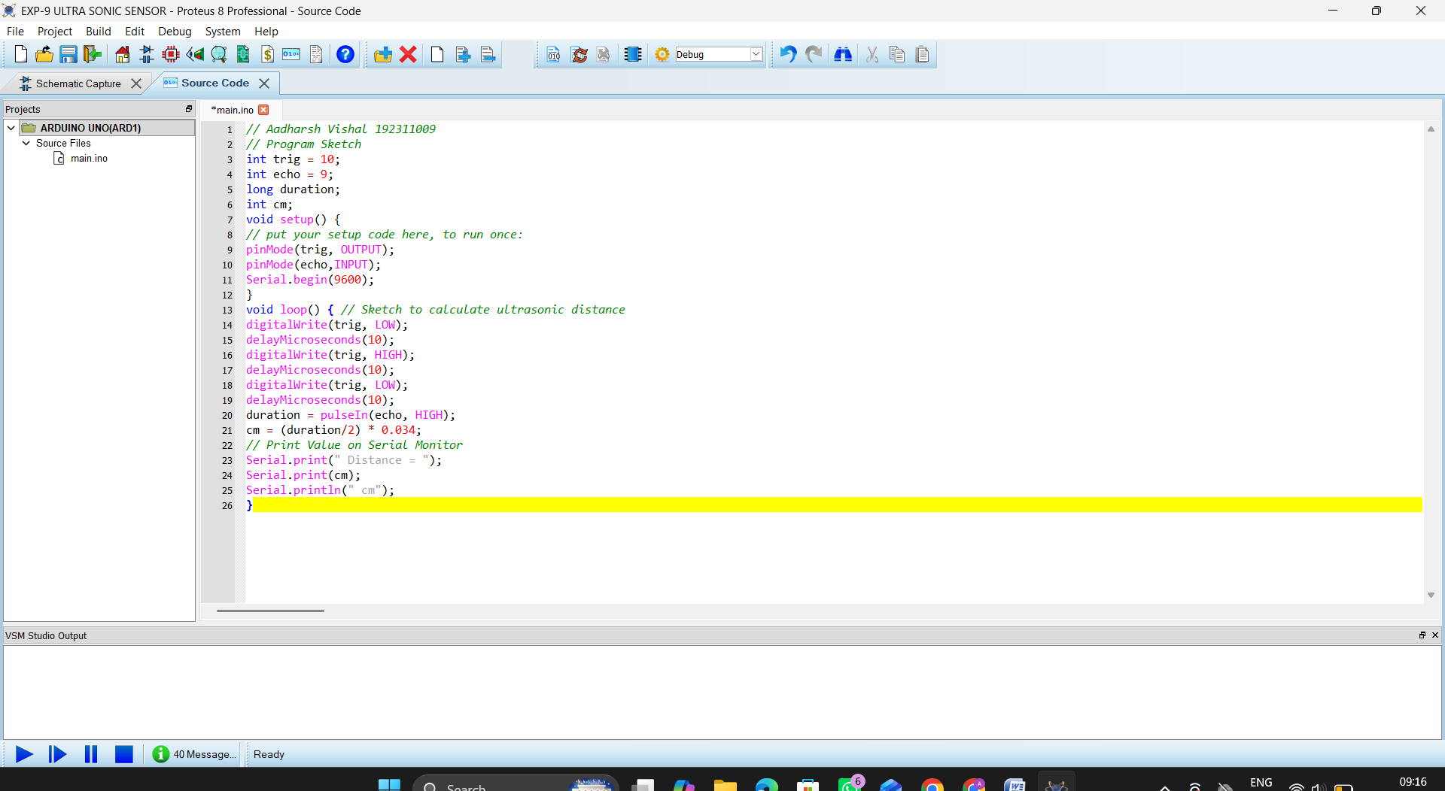

Exp 10: PIR Sensor in Proteus using Arduino
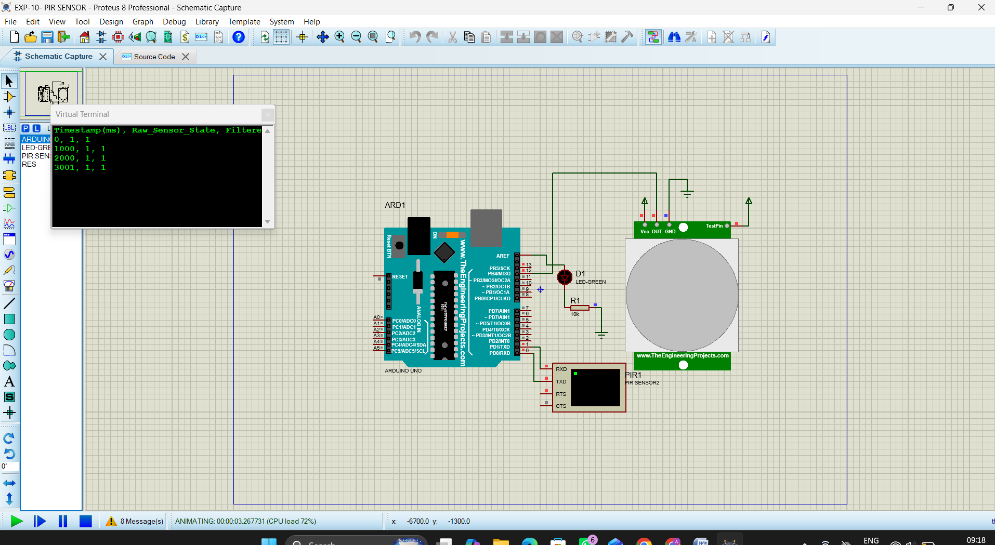
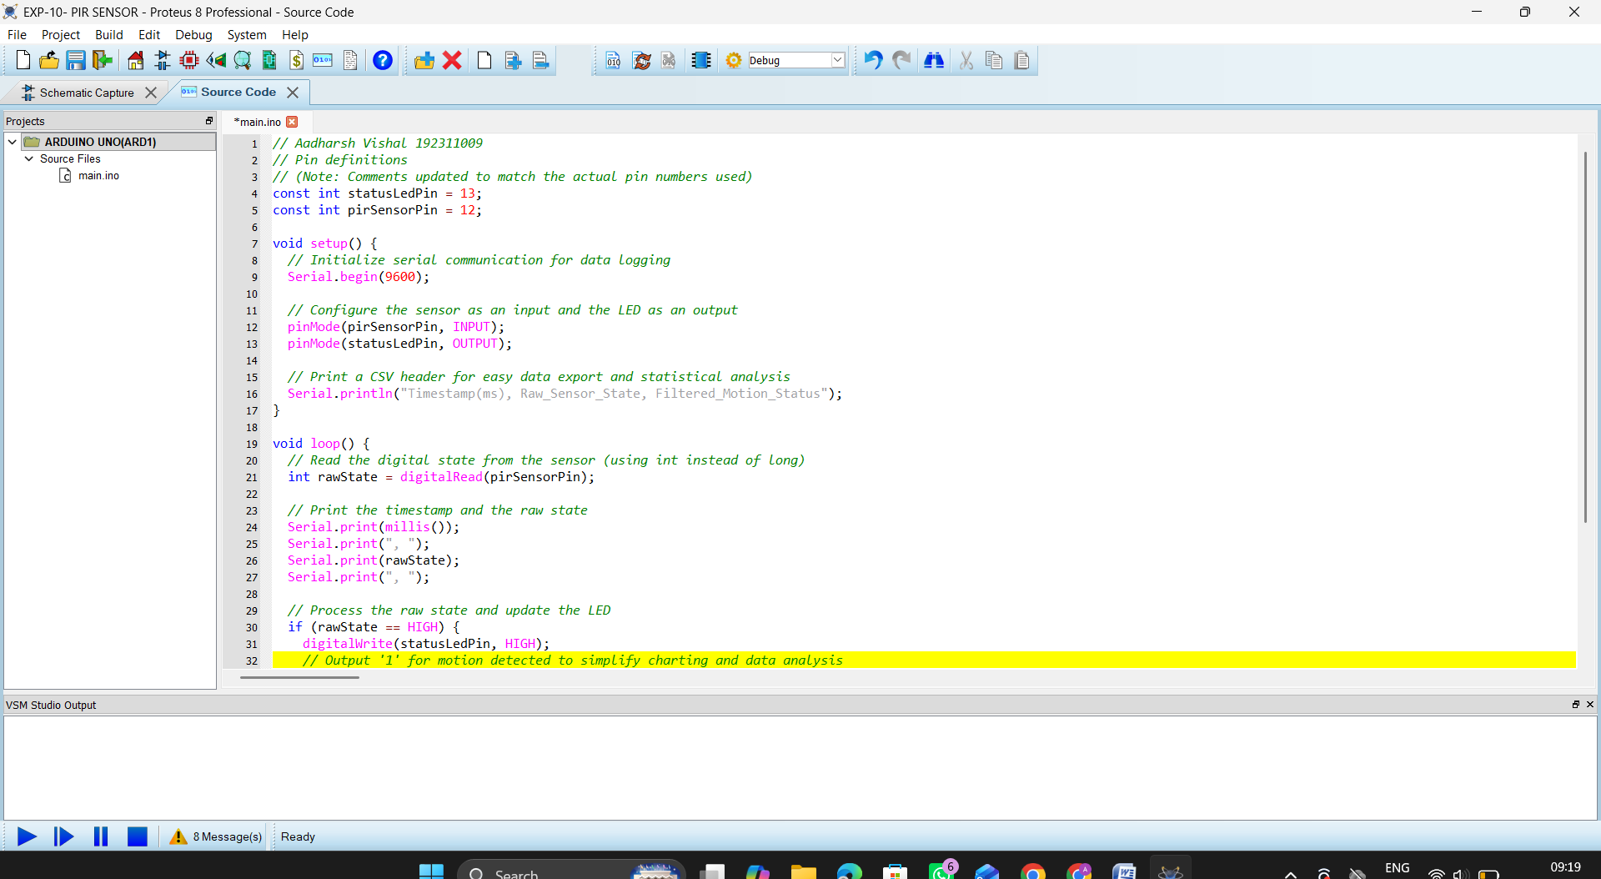

Exp 11: Study of GPIO & Bit Addressing in AT89C51 using Embedded C
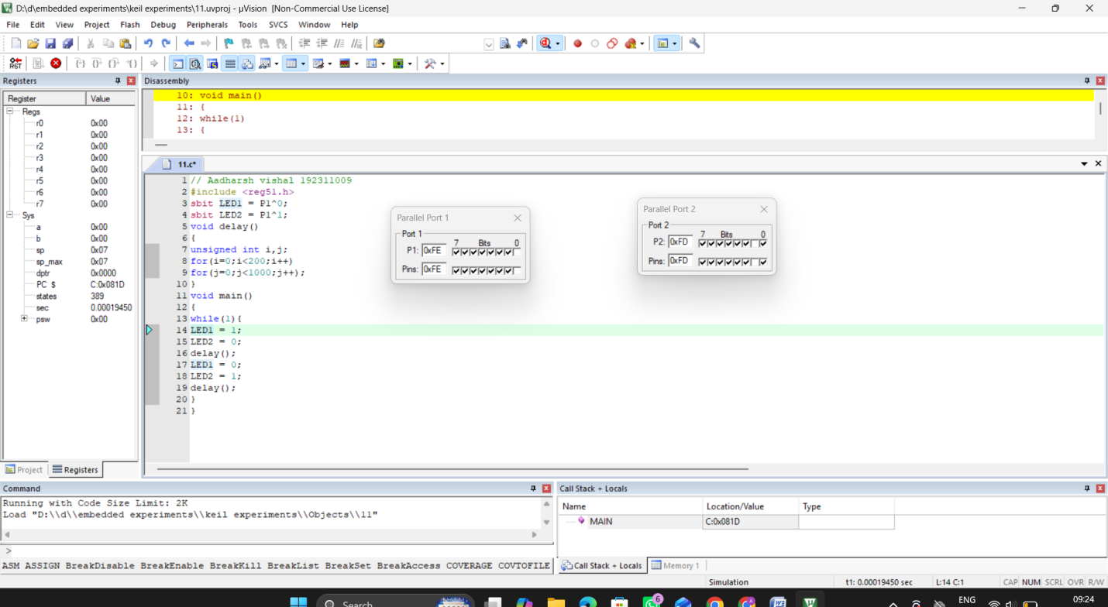

Exp 12: Embedded C program to multiply two 16-bit binary numbers.
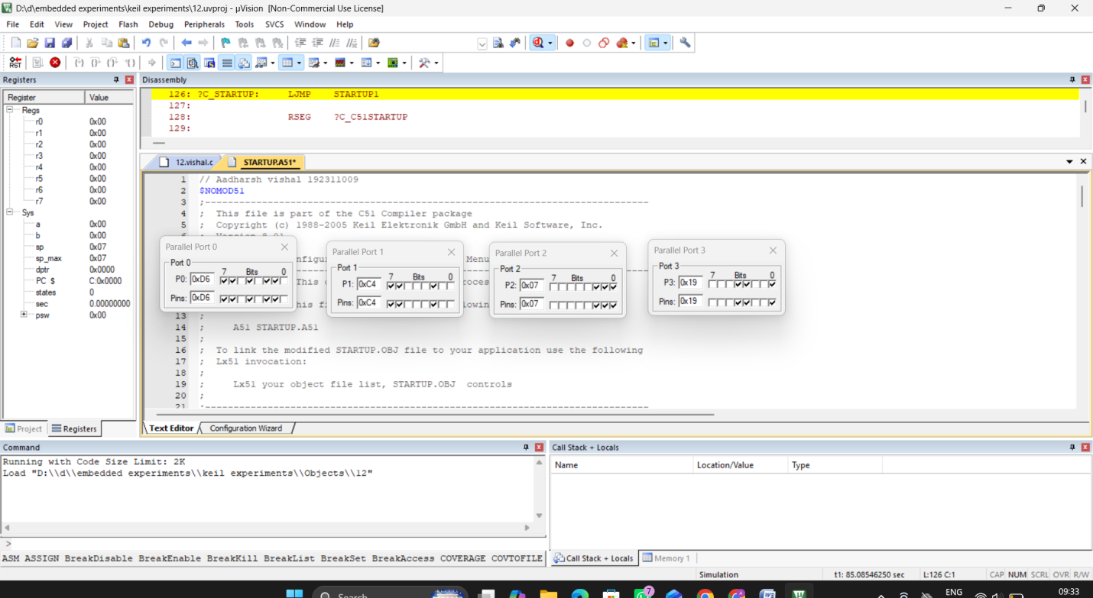
Exp 13: Embedded C program to add an array of 16-bit numbers and store the 32-bit result in internal RAM.
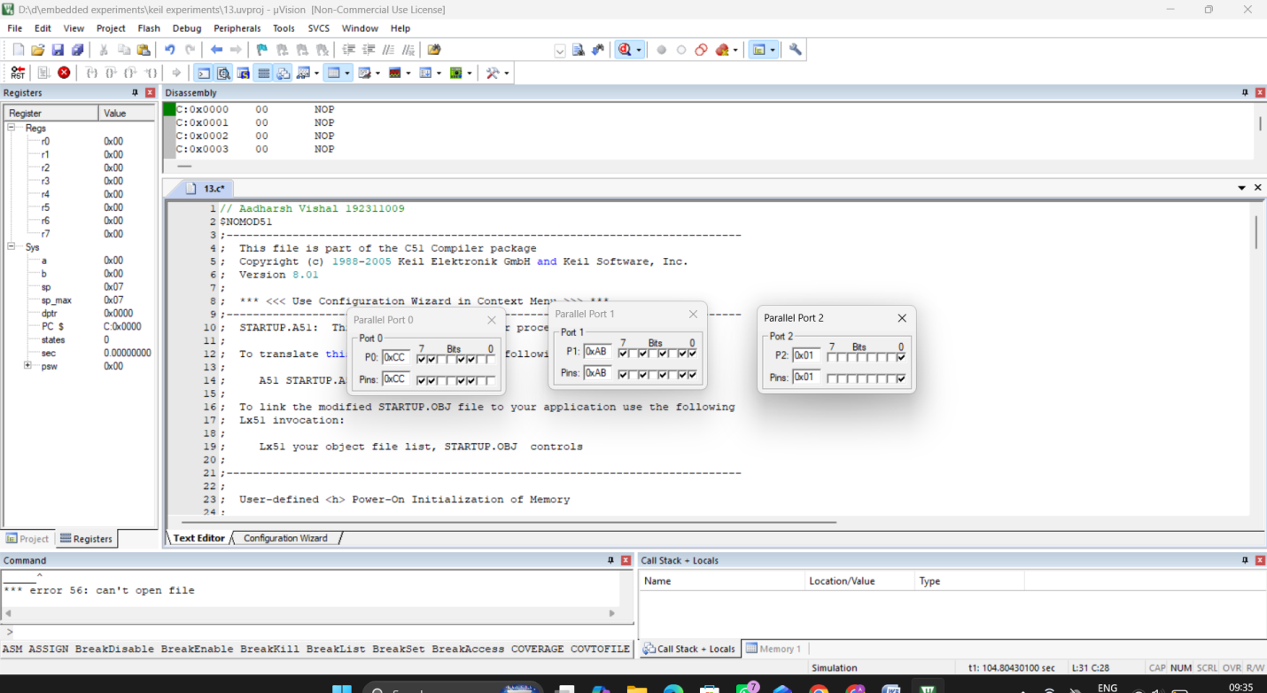

Exp 14: Embedded C program to display “Hello World” message
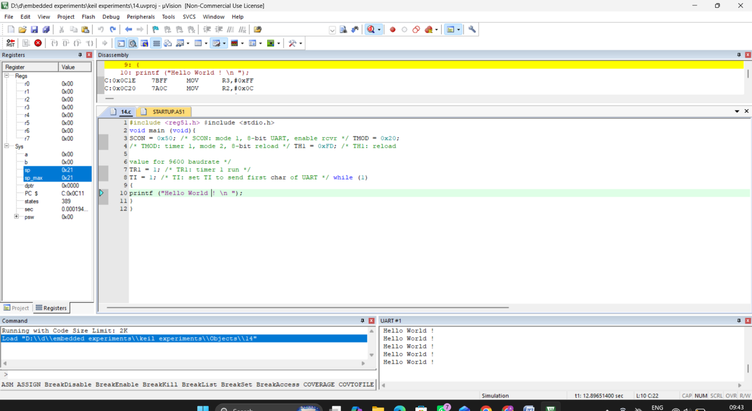
Exp 15: Embedded C program to convert the hexadecimal data to decimal and display the digits on ports P0, P1 and P2
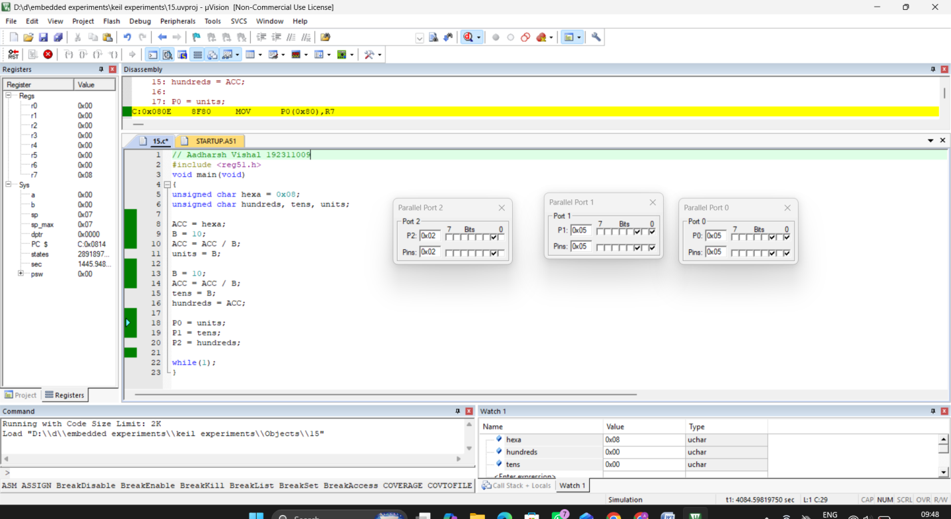

Exp 16: Serial Interrupt Using UART (Keyboard Input) In Keil
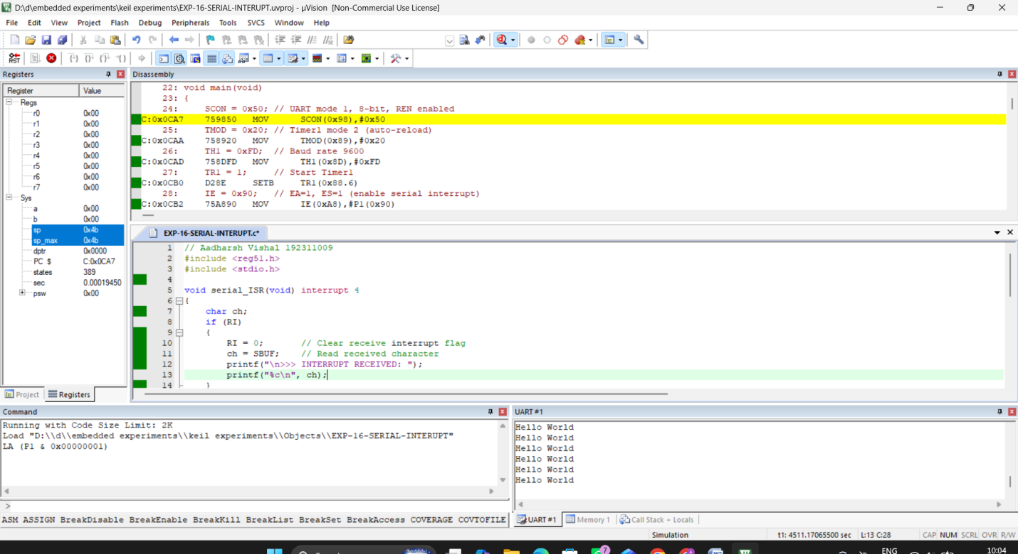
Exp 17: UART Interfacing using Interrupt in KEIL
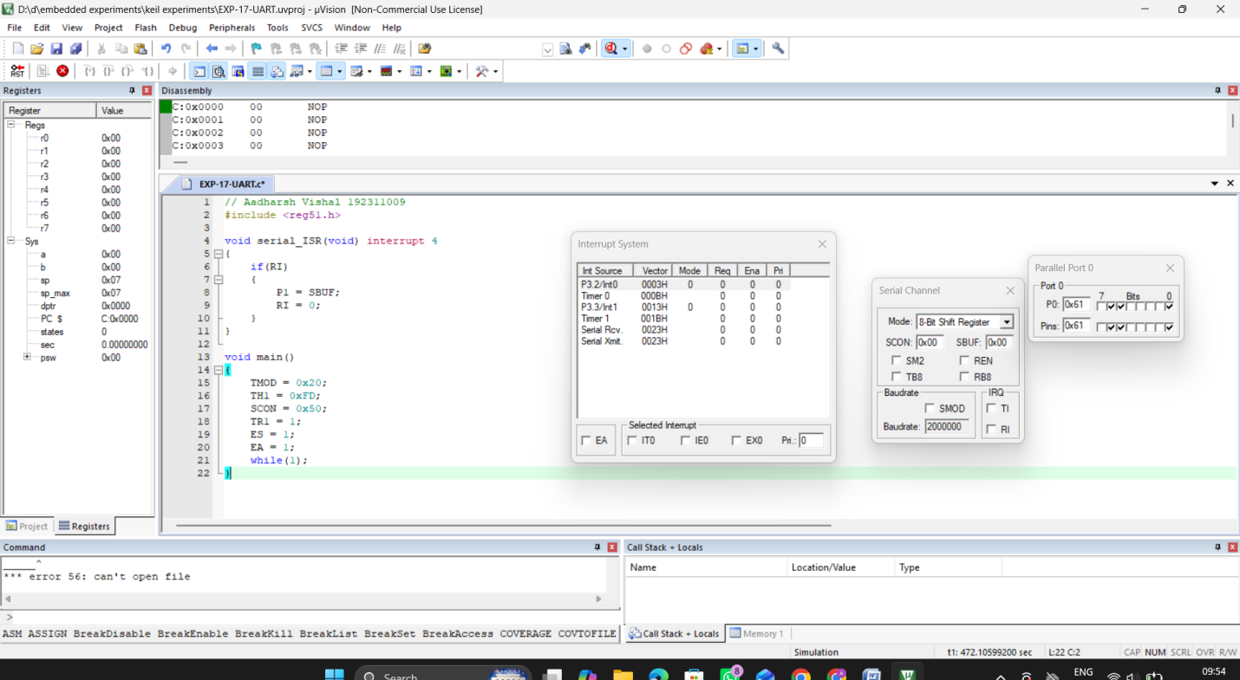

Exp 18: Generation of PWM using TIMER Interrupt
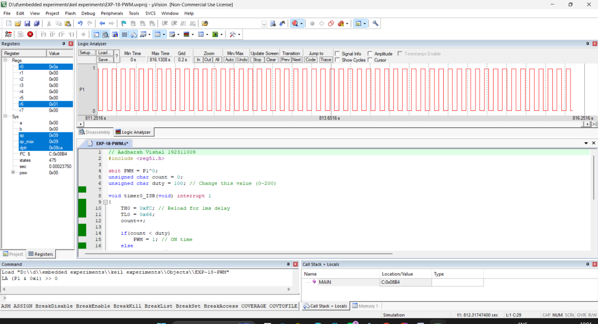
Exp 24: Modeling Clock-Driven Concurrent Processes Using
SC_THREAD and wait() in SystemC
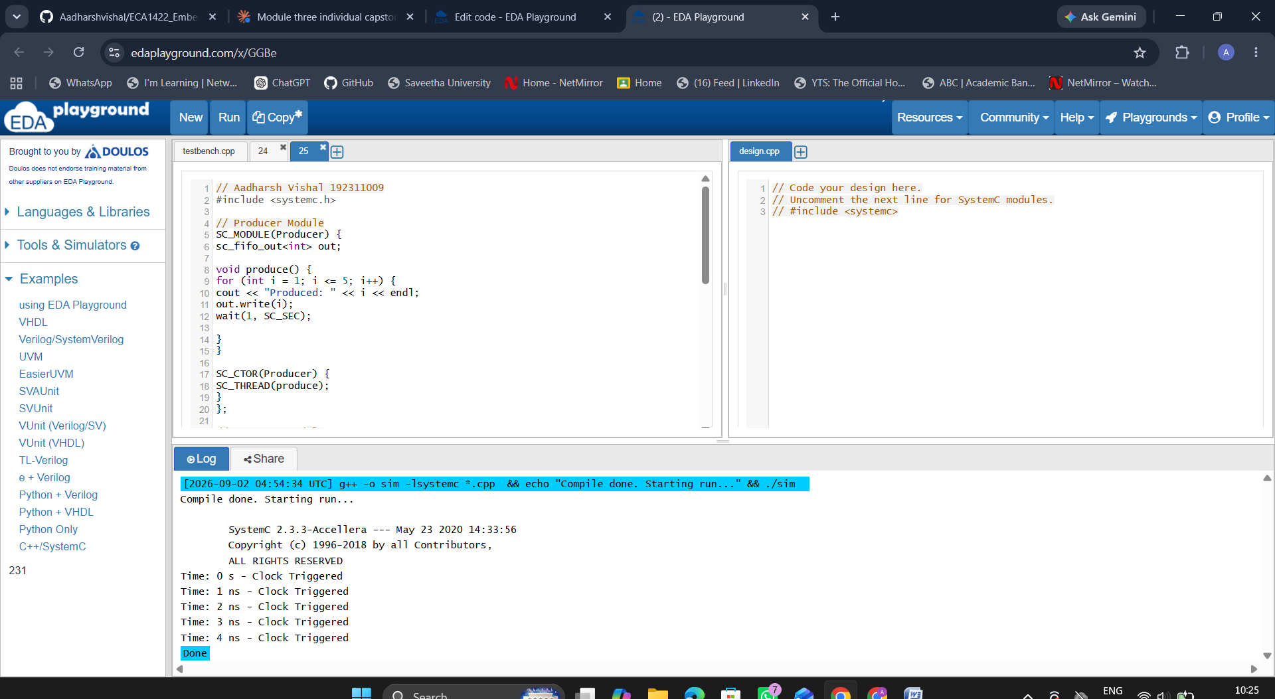

Exp 25: Producer–Consumer Problem Using SystemC
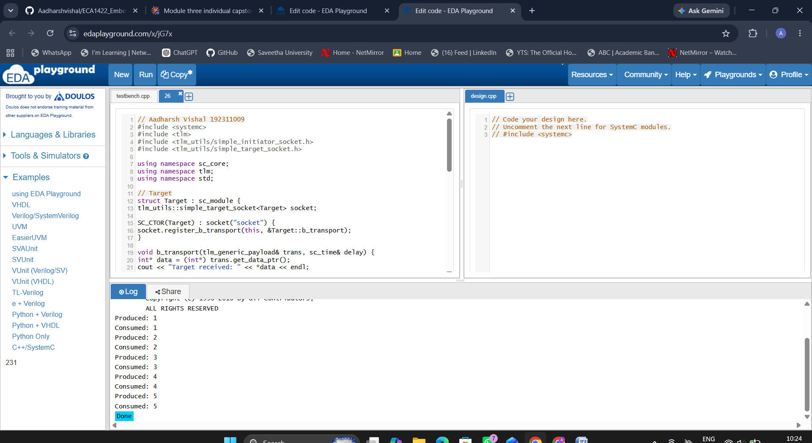
Exp 26: Transaction Level Modeling (TLM) using SystemC
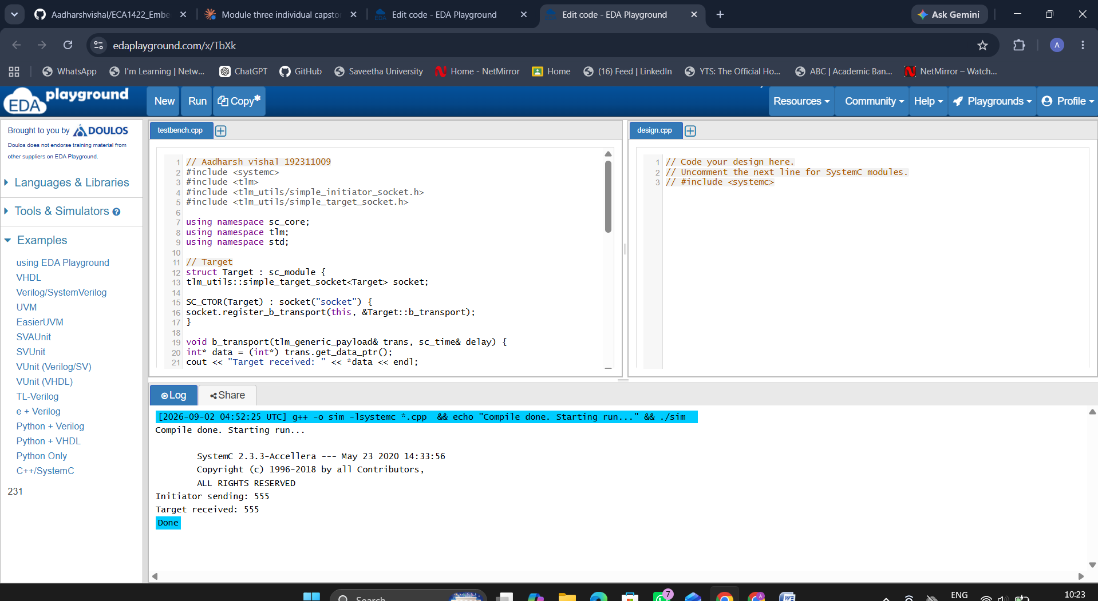

Exp 27: Binary Semaphore in SystemC
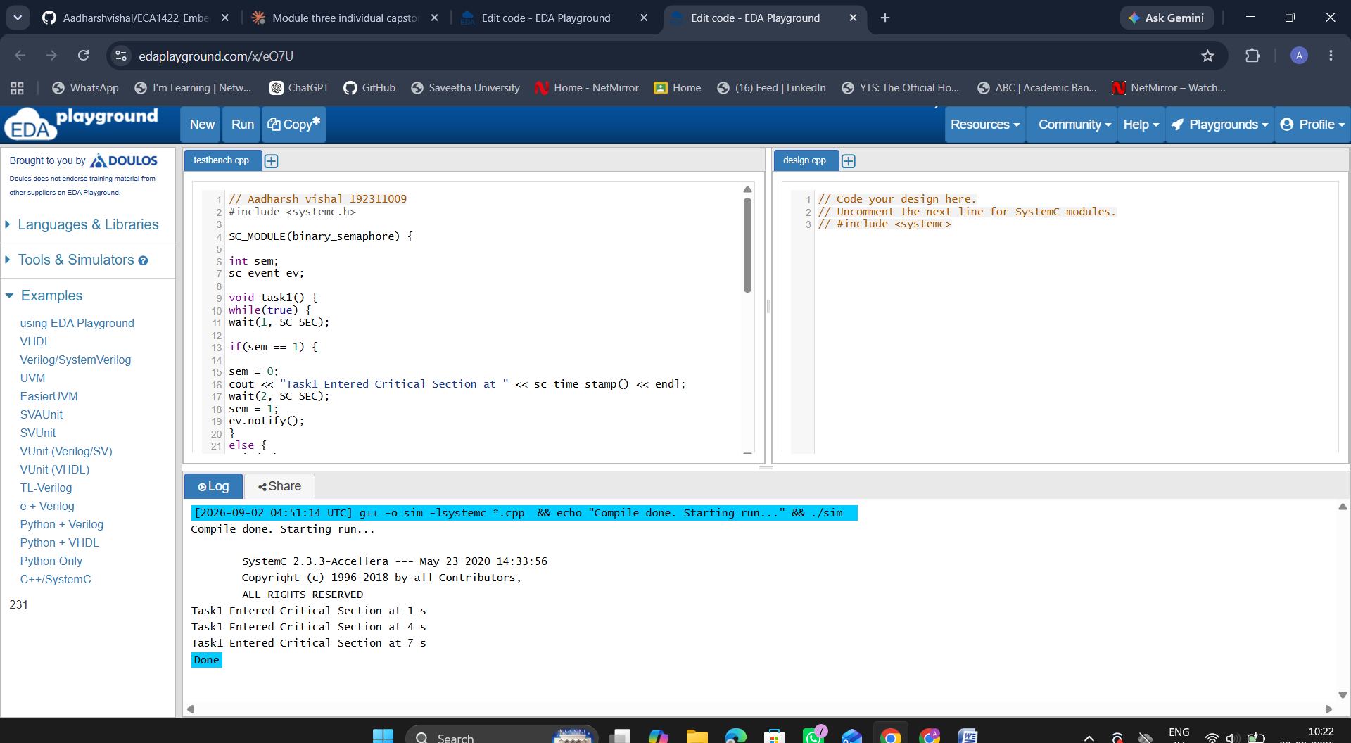

Exp 28: Counting Semaphore in SystemC
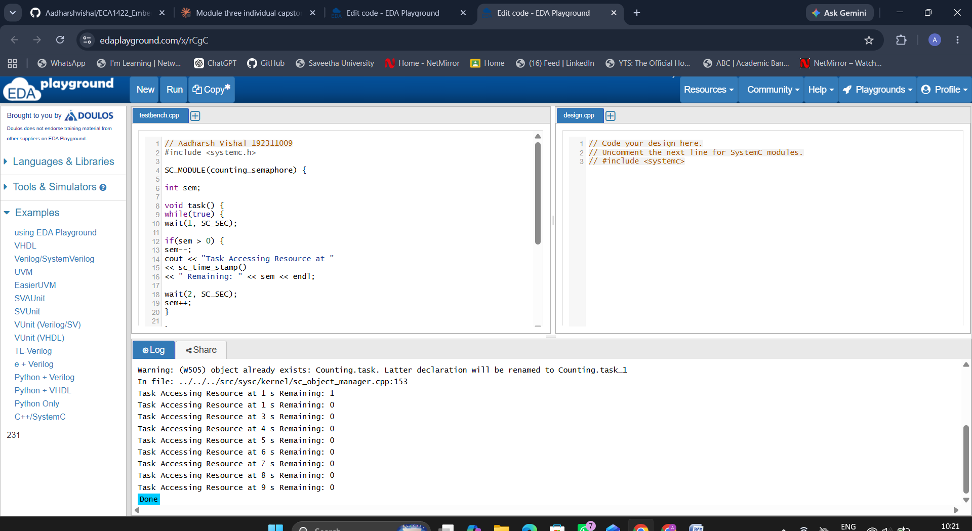

Exp 29: Priority-Based Interrupt Handling
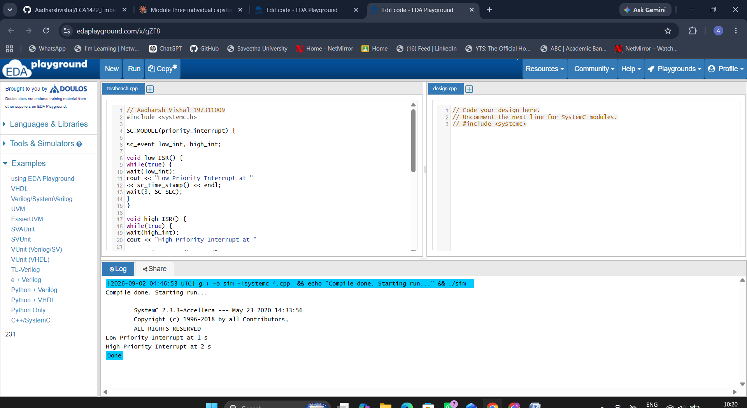

Exp 30: RTOS Task Scheduling
